HUNGARY 匈牙利
Corporate taxes and other direct taxes
A new flat corporate income tax rate of 9% was introduced in Hungary as from 2017. The tax base is the pre-tax profit modified by several increasing and decreasing items. In Hungary, the losses can be carried forward for 5 years. Moreover, the losses may be used for reducing the tax base only up to 50% of the tax base calculated without the loss carried forward. Loss carryback is only possible in the agricultural sector. Special limitations are applicable in case of M&A transactions.

Hungary applies thin capitalization (3:1) and CFC rules. There is a wide range of tax allowances for new investments and R&D. Furthermore, Hungary provides tax exemption on holding structures: capital gains on shares and intellectual property under certain conditions are tax free, and a 50% tax allowance is applicable on royalty incomes. There is no withholding tax on dividends, interest and royalty paid by a Hungarian company to a foreign company. Hungary has a wide international treaty network with more than 80 treaties on the avoidance of double taxation.

The local business tax of maximum 2% is payable on gross margin (sales revenue deducted by COGS, mediated services, material costs and R&D costs). A special surtax applies to the energy sector (31% of the taxable profit, payable in addition to the corporate income tax) and the bank sector (the tax is based on the total assets as of the statutory accounts of the second year prior to the tax year). From mid-2014, Hungary introduced a new advertisement tax which is paid on the sales revenue resulting from advertisement services (and also on the costs of self-advertisement). Small companies may benefit from a special multi-component taxation system (“Kiva”).

Transfer tax is applied in Hungary to a limited scope of transactions. The general transfer tax rate applied to real property transactions is 4%. In case of acquiring a real property (as an asset) or 75% of the quotas of a real property holding company, 4% applies up to a fair market value of HUF 1 billion; and 2% above the threshold, maximized at HUF 200 million tax/real property. The transfer tax is 18% on gifts and inheritance, 9% in case of flats; gifts and inheritance within family is tax-exempt.
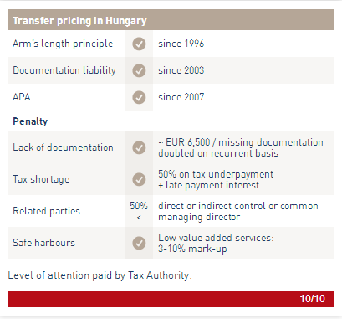
VAT and other indirect taxes
Hungary runs a VAT system complying with the EU VAT Directives. The standard rate is 27%, while the reduced rates are 18% (e.g. bread, internet access service, accommodation services) and 5% (e.g. milk, eggs, journals, books, medicines, certain meat products, new homes and central heating). The options/limits based on the EU Directive are presented within VAT legislation:

Due to the limited voluntary compliance in certain sectors (e.g. retail business and certain services), Hungary introduced a number of measures aiming at enforcing the law, such as the online control of cash registers, domestic sales reports are also required. In order to prevent “carousel” fraud, an online registration of the international transportation of products has been required since 1 January 2015. Although all of these measures aim to reduce the extent of the black economy and tax evasion in Hungary, they also cause a relatively high VAT administration burden for the taxpayers. As from mid-2017 taxpayers will be required to use billing software capable of providing the tax authority with real-time data.

Other indirect tax types in Hungary include excise duty on oil, alcohol and tobacco products, environmental protection charge on products heavily polluting the environment (e.g. all kinds of electric equipment, accumulators and batteries, packaging materials, etc.), financial transactional tax (payable by the banks completing such transactions), insurance tax and 'chips tax' (levied on unhealthy foods and drinks).
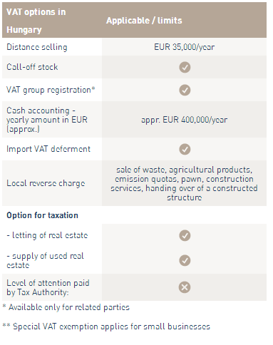
Personal income tax / Social security system

There is a flat rate of PIT since 2013, which has been reduced to 15%, and it is generally applicable both to active (e.g. employment, assignment fee) and passive incomes (e.g. capital gains, dividend and interest). Tax payable on active incomes is reduced by a family tax allowance.

The amount of the family tax base allowance is HUF 100,000/month/child up to 2 children (meaning the tax allowance is HUF 15,000 (appr. EUR 48)/child); and HUF 220,000/month/child from 3 children (in which case the tax allowance is HUF 33,000 (EUR 110)/child). The family tax allowance may be also deducted from the social security contributions payable by the employee (up to 17% of the gross salary), if the PIT base is less than the maximum amount of family tax base allowance.

Active incomes fall under the scope of the SSC system: social security contributions payable by the individuals concerned equal altogether 18.5%; the employer’s contribution has been reduced to 23.5%. Passive incomes are subject to different rates of health care tax depending on the income type: 14% with a low threshold (e.g. on dividends, capital gains, real estate rental income); or 27% (e.g. income on selling rights); or they are exempt from health care tax (e.g. capital gain on shares of stock exchange, or interest).

Benefits-in-kind are taxed at two rates: PIT plus health care tax calculated on a special tax base altogether amounting to 34.22% or 43.66% and payable only by the employer. The examples below show the wage cost of the employer and employee at the minimum wage level and at the average wage in the private sector.
